**Hackathon day 3**

**Anoosha Naz 00064668**

**Monday 2 to 5**

**Marketplace Name**

**Comforty Ecommerce Website**

**Introduction:**

Welcome to the hackathon day 3! Template number **8** in Figma. We are building **Comforty**, a chair marketplace. Previously, you’ve focused on developing the frontend. In this hackathon, we aim to extend functionality by integrating **Sanity** to manage product data efficiently.

Api Keys of template 08

<https://giaic-hackathon-template-08.vercel.app/api/products>

<https://giaic-hackathon-template-08.vercel.app/api/categories>

Step 1:

Create new nextjs project.for this command

(npx create-next-app .)

Step 2:

Install sanity studio for this command

npm create sanity@latest -- --template clean --create-project "Hackathon03" --dataset production

1. It will ask you the following questions.
   * Would you like to add configuration files for a Sanity project in this Next.js folder? Yes
   * Would you like an embedded Sanity Studio? Yes
   * Would you like to use the Next.js app directory for routes? Yes
   * What route do you want to use for the Studio? /studio
   * Select project template to use Clean project with no predefined schemas
   * Would you like to add the project ID and dataset to your .env file? Yes
2. Wait a bit for the installation process to complete. When get a Success!

**Step 3: Run the Studio locally**

npm run dev

This will start the next js project. Once the build is complete, you can head over to http://localhost:3000/studio. It will ask you to add the URL as a CORS origin. Click on Continue to open the Sanity management dashboard.

**Step 4: Define Sanity Schema**

Create two Schema files which name is product.ts and categories.ts.

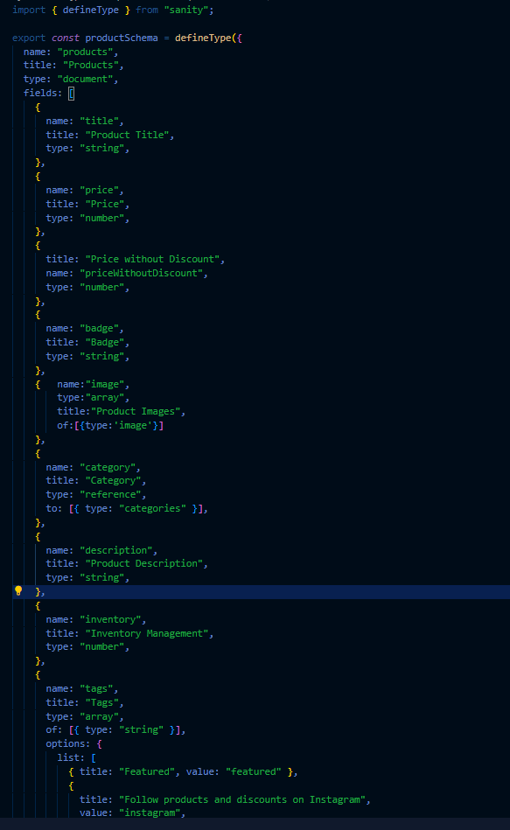

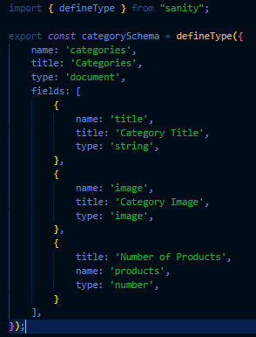

#### **Step 4**: **: Import the Schema files in index.ts**

#### [**src/sanity/schemaTypes/index.ts**](https://github.com/Hamzah-syed/giaic-hackathon-template-08/blob/master/src/sanity/schemaTypes/index.ts)

import { type SchemaTypeDefinition } from "sanity";

import { productSchema } from "./products";

import { categorySchema } from "./categories";

export const schema: { types: SchemaTypeDefinition[] } = {

types: [productSchema, categorySchema],

};

#### **Step 5** **: Data migration script**

1 create env file for the script.

Like that NEXT_PUBLIC_SANITY_PROJECT_ID="<Project ID>" # Add your project Id

NEXT_PUBLIC_SANITY_DATASET="production"

NEXT_PUBLIC_SANITY_AUTH_TOKEN="<Auth Token>" # Add your token

2 create a folder which name is script and create file inside this folder whose name is migrate.mjs

3 Open `package.json` file and add the following code inside of scripts: "migrate": "node scripts/migrate.mjs"

4 Install the following package before running the script.

* 1. npm install dotenv

5 Now run the command npm run migrate

6 This will insert the data from the rest api to sanity studio.

**Step 6** **: Rest API endpoint for Details:**

**Products API**

* **Endpoint:** [**https://giaic-hackathon-template-08.vercel.app/api/products**](https://giaic-hackathon-template-08.vercel.app/api/products)

**Categories API:**

* **Endpoint:** [**https://giaic-hackathon-template-08.vercel.app/api/categories**](https://giaic-hackathon-template-08.vercel.app/api/categories)

**Step 7: My progress show in this picture:**

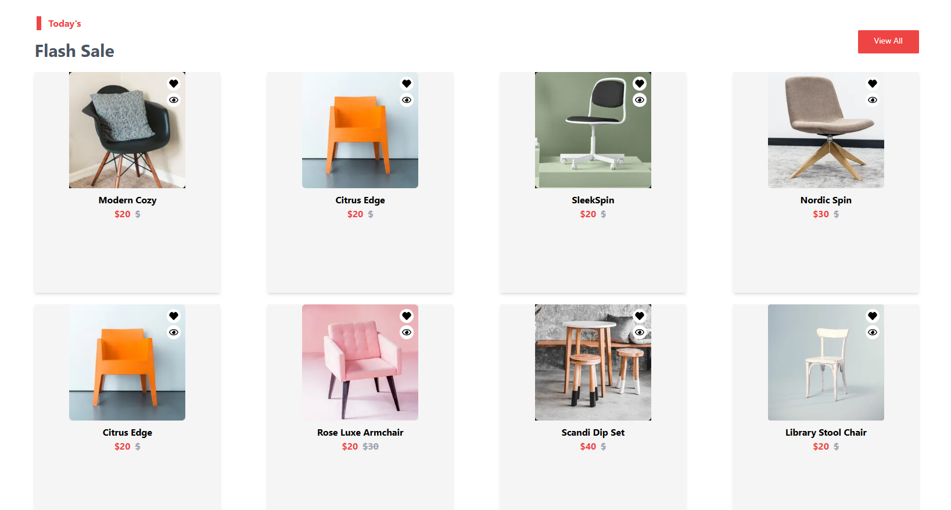

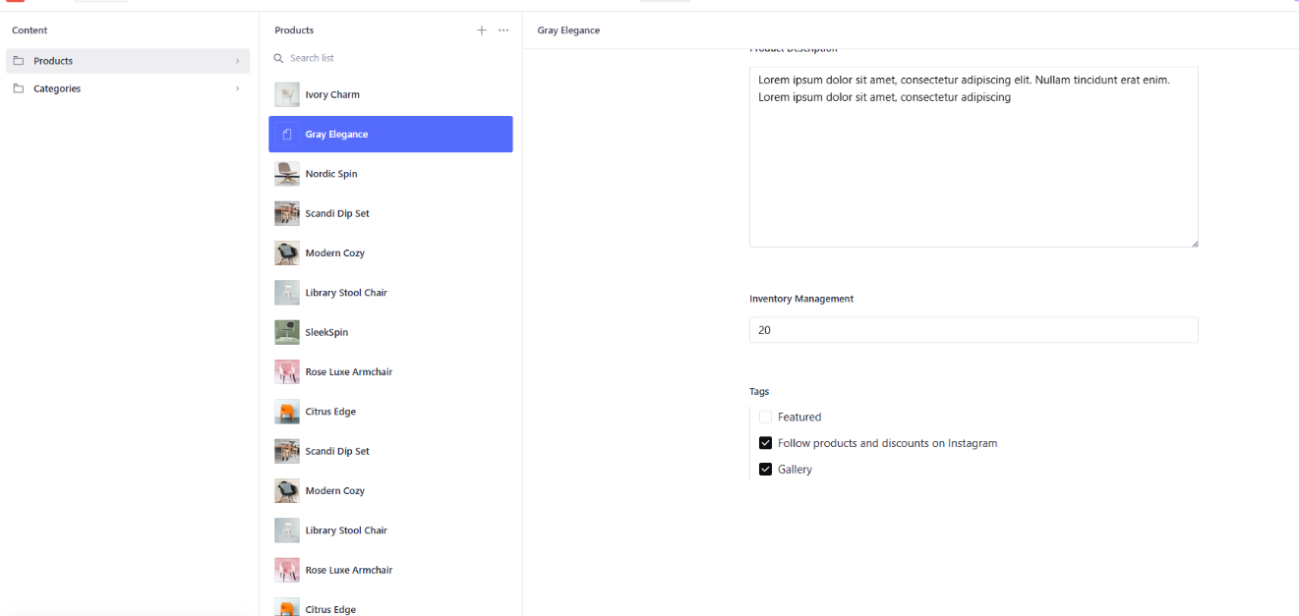

**Step 8: GROG Query Pic**

